**MUJTABA SHAHID FAIZI**

**BSCS-5A**

**#131818**

**LAB 8 OF AP**

**Introduction**: Create a new database in MySQL, using the name defined in hibernate.cfg.xml file. Build the given system using Maven. Change the Inheritance types from Table per Hierarchy to Table per Union Sub Class and Table per Joined Sub Class. The main will insert some new elements in your table.

**Analysis:** In table per hierarchy, we represent all fields in a single class. There are no joins between tables improving performance, but we cannot set values to NULL since it will not update the value in every table. In JOIN, the primary key of parent is used as foreign key in child class. I have 4 tables in join hierarchy. In UNION, all the data from parent class is passed to class. In this task, we have 4 tables in UNION as well.

**INHERITANCE 1:**

**Table per hierarchy:** Table: emp_unionsubclass

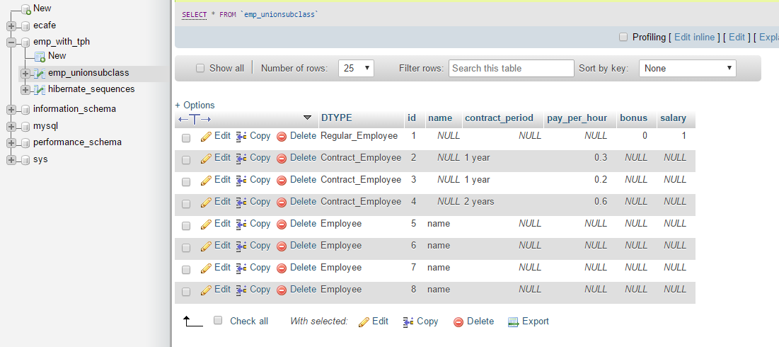

**INHERITANCE 2:**

**Table per joined subclass:**

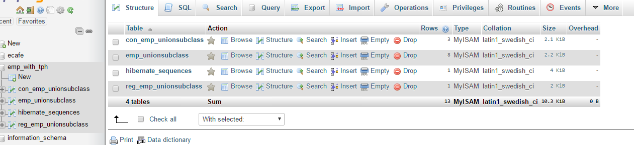

Table: con_emp_unionsubclass

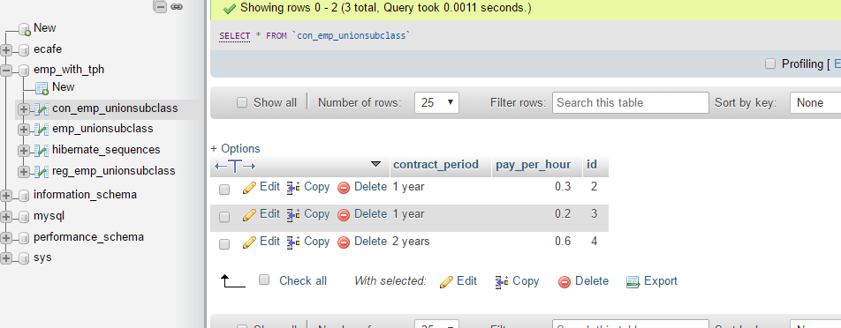

**INHERITANCE 3:**

**Table per Union Sub Class**

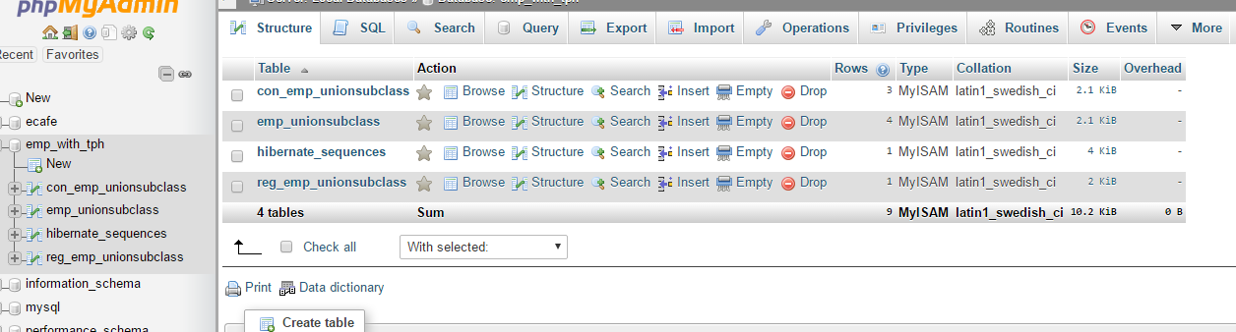

Table: con_emp_unionsubclass

